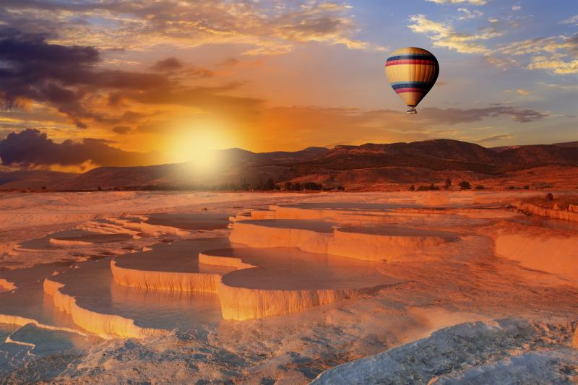
Turkey is a country surrounded by seas from three sides which has many historical and natural attractions with hospitable and smiling people, with large green forests and long beaches, it is like a paradise…

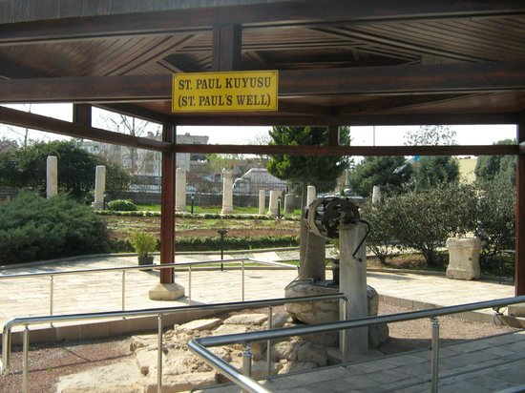
Our school is located in Tarsus, Mersin. It is 30 km far from Mersin and 45 km from Adana that is famous for its delicious meal like Kebab. Mersin is in the South coast of Turkey that has precious shores you can find one of the cleanest beaches of Turkey. Tarsus is an awesome city that was home to many civilizations in hundred years. Roman Way, Kleopatra Gate, St Paul Well, Eshab-ı Keyf (the cave of seven sleepers) and Taşkuyu Cave (a big and fantastic cave) are tourist attractions.
Our school has two buildings, 20 classrooms, a meeting saloon and a laboratory. It trains students with dual education (not only in the mornings but also in the afternoons). There are 936 students in the school. There are also two pre-school classrooms that have 52 students.
Our school has very little experience in European Project. We made KA1 project in 2015 and also KA2 project with Romania and Portugal. But we had no luck. We are ready to make an effort with our teachers of the school. We are eager to participate in both KA1 and KA2 project.

